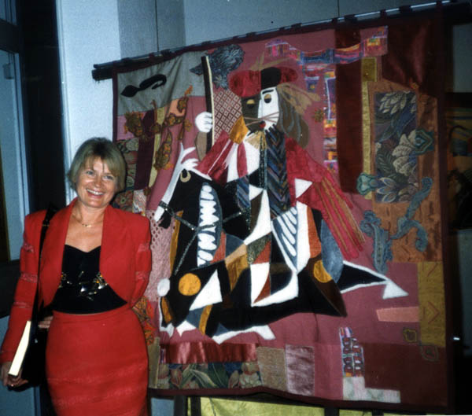
swava
Swava Launay was born in Poland. She studied literature at Jagiellone University in Cracovia and at the Sorbonne in Paris.
At the School of Fine Arts in Vallauris, she learns different visual art techniques, but she chooses textile art under the influence of both artists and Ukrainian Joanna Winnikow, Joury Koultchytski who also lived in Mougins. Through this meeting was born a special technique between patchwork and pure weaving the "Contemporary Tapestry"
Works of Swava have been exhibited in galleries abroad; Philadelphia P.A. USA, Manhattan, New York; Gildo Pastor Center, Monaco; Krakow Poland; Vilnius, Lithuania; Brussels; Vienna Austria; Sao Paulo, Brazil; Montreux, Rapperswil, Switzerland ...
They are on permanent display in the City Halls of Mougins, Beausoleil, Eiguilles. As well as in the private collections of Mr. Lenotre, Texas; Mr. Chelkowski, New York; Hélène Pastor, Monaco.
They participated in the International Art Festival in Krakow and textile art "look at Europe" exhibition in Strasbourg.

